**CSC 642 | Group 10**

Andre Lavilla

Leilah Lui

Tyler Fulinara

Marie Shimizu

William Chin

Product Name: Up-Down-Town

**February 24, 2023**

# Overview

In supporting a caring world, our platform will facilitate collaboration and public participation; individuals and their communities need a platform where they can be recognized, have a sense of identity, and feel connected with their community. Our users will be able to easily connect with others by remaining informed on city events and activities, and voicing their thoughts or sharing their unique perspectives on different aspects of their city.

# Objectives & Goals

1. **Solve the problem of communities not feeling inclusive with other communities :** Existing methods of communication between city leaders and city civilians, like city websites and publications, social media, and public city council meetings, can feel like a form of one-way communication. Collaboration requires two-way communication between city leaders and city civilians.
2. **Solve the problem of communities and individuals not having a sense of identity:** Underrepresented individuals and communities can feel unincluded or detached from their communities for various reasons. The ability to connect with others in one’s geographical area or share a common interest can help boost and encourage overall public participation

# Analysis of the current problem

City leaders—those that make administrative decisions for the public—and city civilians—those whose lives are impacted by decisions made by city leaders—need a platform to unite and support the diversity of communities that exist in their city. Ensuring the public’s satisfaction with the quality of living in a city is a collaborative effort among city leaders and the diverse communities they represent.

Currently, city leaders struggle to maximize public engagement for various reasons. The challenges that come with current methods of public engagement and participation can involve cost, a lack of a skilled facilitator, low efficiency, low interest, and language barriers. City websites and publications, social media, and public city council meetings aren’t enough with these challenges at hand. These challenges ultimately hinder collaboration and, thus, the ability to achieve a common goal of improving and maintaining the city’s quality of living.

# Options that are currently available

Existing platforms such as NextDoor, Ring, Facebook, Reddit, and Twitter do a great job of keeping the online space casual and approachable, but they don’t quite meet our needs. Our vision is to create a platform like NextDoor, but implement some of the core features from other services such as Ring, Facebook, Reddit, and Twitter.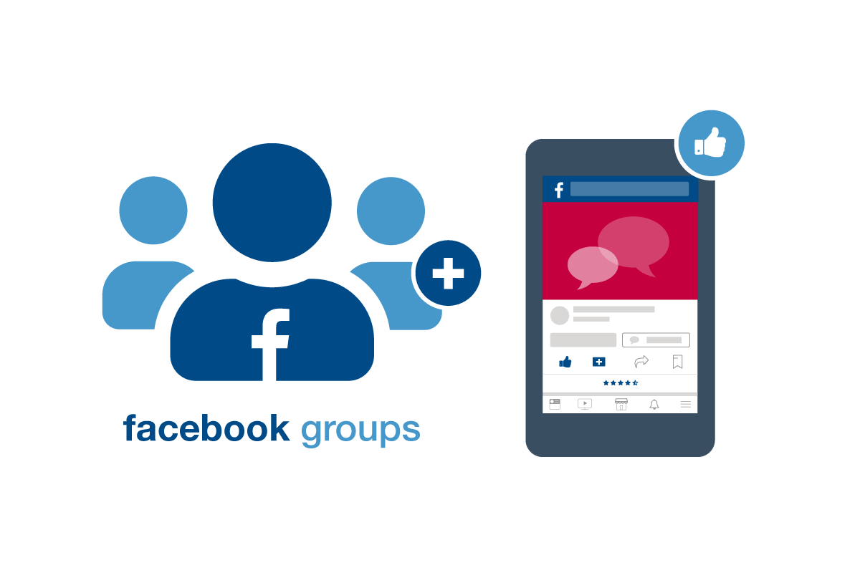

1. Facebook: Facebook has a wide user base with a diverse range of interests and communities making it easy for users to view or join groups and events for their respective interests. However, Facebook also tends to prioritize popular/clickable content over meaningful community posts and is overrun with a lot of spam. 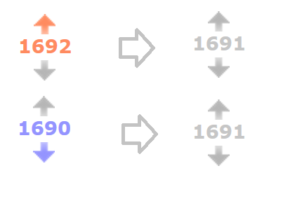
2. Reddit: Reddit has a strong focus on community and discussion with great solutions to spam: upvoting and downvoting posts. This system helps prioritize important/meaningful content while keeping spam and junk hidden from a majority of users in the community.
3. NextDoor: Meanwhile, apps like NextDoor have a hyperlocal focus on neighborhood-based communities, but lack support due to the small scale of users. Moreover, NextDoor lacks accessibility to news, events, and posts for members outside their neighborhoods. 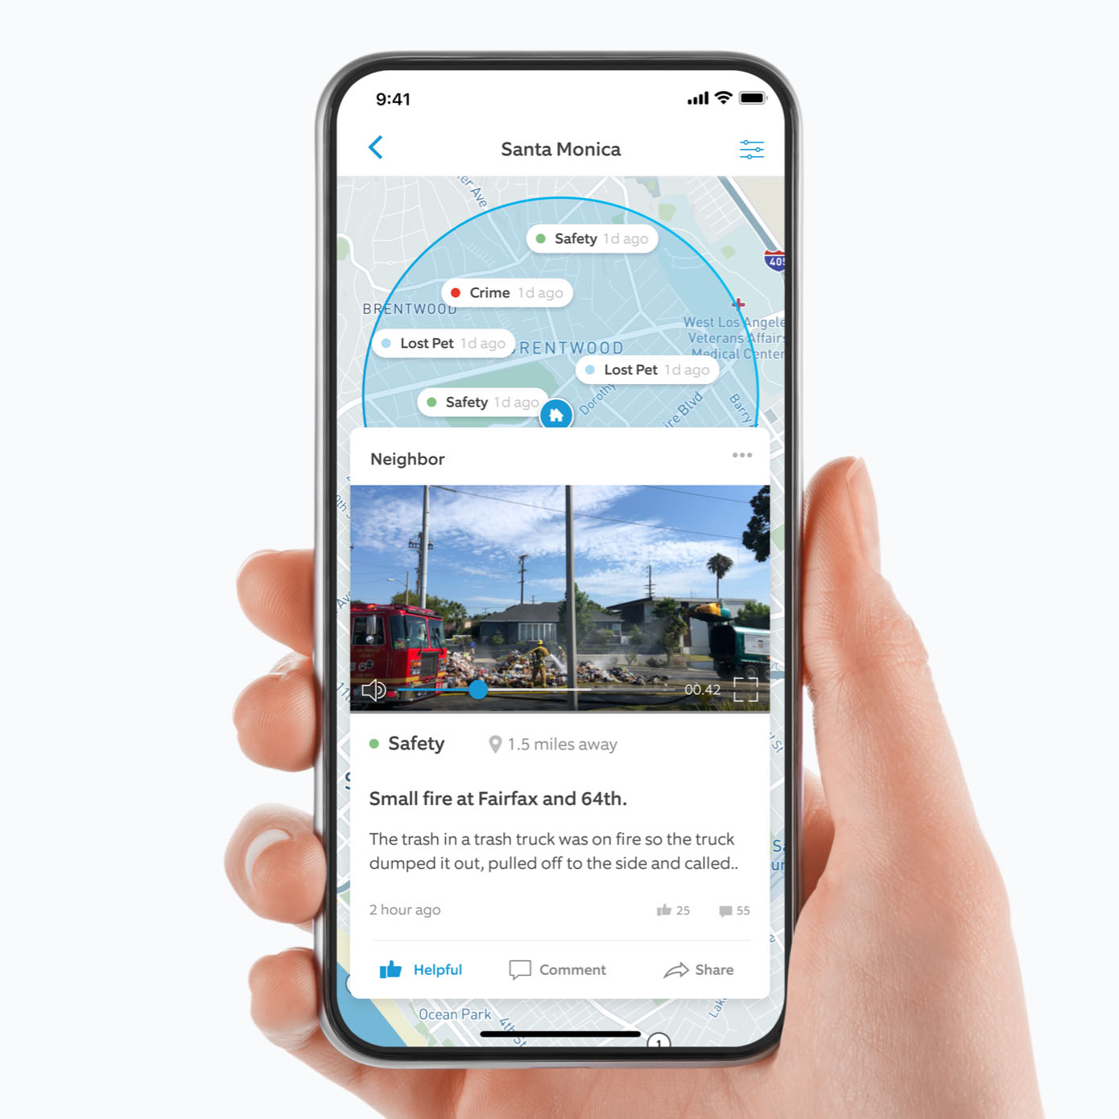
4. Ring: Similarly, Ring (another neighborhood-focused app) implements an incident map with events (lost animals, community meetings, community crime reports) all within a certain range of the user. Unfortunately, there is a lot of spam as Ring doesn't have a great system for filtering out videos and posts.

We are interested in incorporating Ring’s incident map and Facebook’s community accessibility features, while expanding it so that users can click on a district of San Francisco and have all posts separated into different categories via buttons. 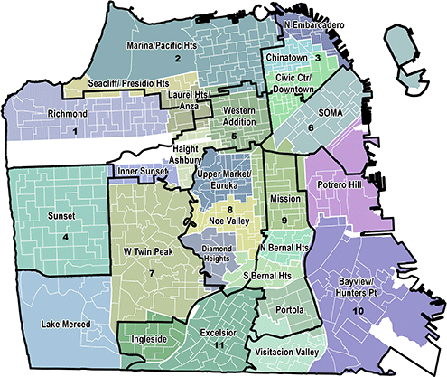

Then we can implement some of Reddit’s core spam functionalities with their upvoting and downvoting system improving user experience. Furthermore, we are looking to leverage Twitter’s implementation of checkmarks (gold, blue, gray, or none) to manage community engagement.

# Target Users

The users of our platform can be anyone! Our product will be designed to benefit people of all ages, abilities, rage, genders, economic status, etc.

1. **Primary Users :**
   1. People of all ages (that have a smart mobile device), genders, abilities, economic standings, races, etc.
   2. Members of neighborhoods/communities (urban and suburban)
   3. People who like to be involved in their communities, explore, and travel
   4. People who want to learn more or research specific communities
   5. People looking for a new place to live
   6. Homeowners
2. **Secondary Users:**
   1. Community Event Organizers
   2. Police Officers/Law Enforcement
   3. Home/Residential Construction Companies
   4. City Councils
   5. Travel Agencies

# Our approach to supporting a caring world

Supporting a caring world could mean what we could provide or assist others to make the world more supportive and have a sense of togetherness. Care is currently enacted in the setting of media—including social media, journalism, community publications, and more—word of mouth, and connections among community members. Current usage of social media platforms involves user activity that can assist in informing the public and enabling users/community members to connect with others in their community.

In the problem that we are tackling, “care” currently lacks a sense of community, where modern society creates loneliness and people want connection. Creating a community and a connection between people would create many different positive impacts.

Our approach to “care” is to create a platform that will create a sense of community, where people will have a positive feeling where they can connect and feel a sense of inclusion in not only their community but others as well. Being able to include community input in our platform would encourage different communities and individuals to come together showcasing a sense of community and inclusion.

# Our vision for our impact on the future

By incorporating key features from popular neighborhood apps like NextDoor, Ring, Facebook, Twitter, and Reddit, our platform will offer a unique way for people to connect, communicate, and share information about their community. A sense of connection is a fundamental human need, but in today’s modern society, especially during the pandemic, connecting with others has become increasingly difficult.

Our platform will be able to achieve a stronger sense of community and inclusivity among neighbors, making it easier for people to connect and form relationships with others in their neighborhood. By making it easier to communicate about any activities in their neighborhood, and sharing information about the potentially dangerous area, people will be able to make more informed decisions about where to live and explore. Our platform will also be able to bring about a safer lifestyle for users.

There are 4 main factors in evaluating the impact of the platform: response from users, level of user engagement, reviews and ratings on our platform, and crime rate. If successful, our platform has the potential to bring significant positive long-term change, including a decrease in crime rate as the platform will help to increase communities’ criminal-activity awareness. On top of this, our platform could offer tools for law enforcement to better understand and address crime in the communities. Finally, by bringing people to the same area and giving them a platform to voice their concerns and ideas, it could help improve people’s mental health and overall well-being.

# 

# Storyboard Sketches

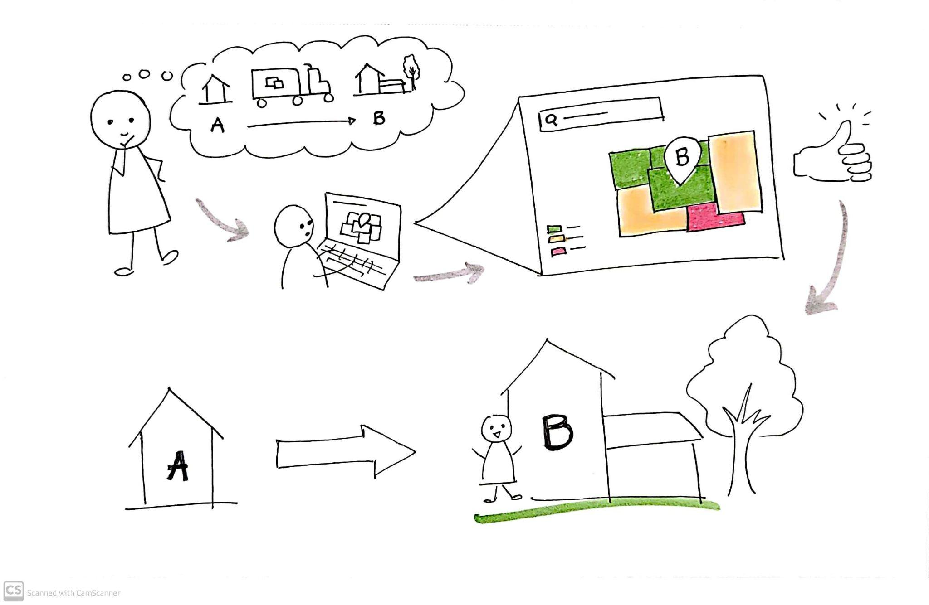Scenario 1: Looking for a new home Scenario 2: Exploring new places

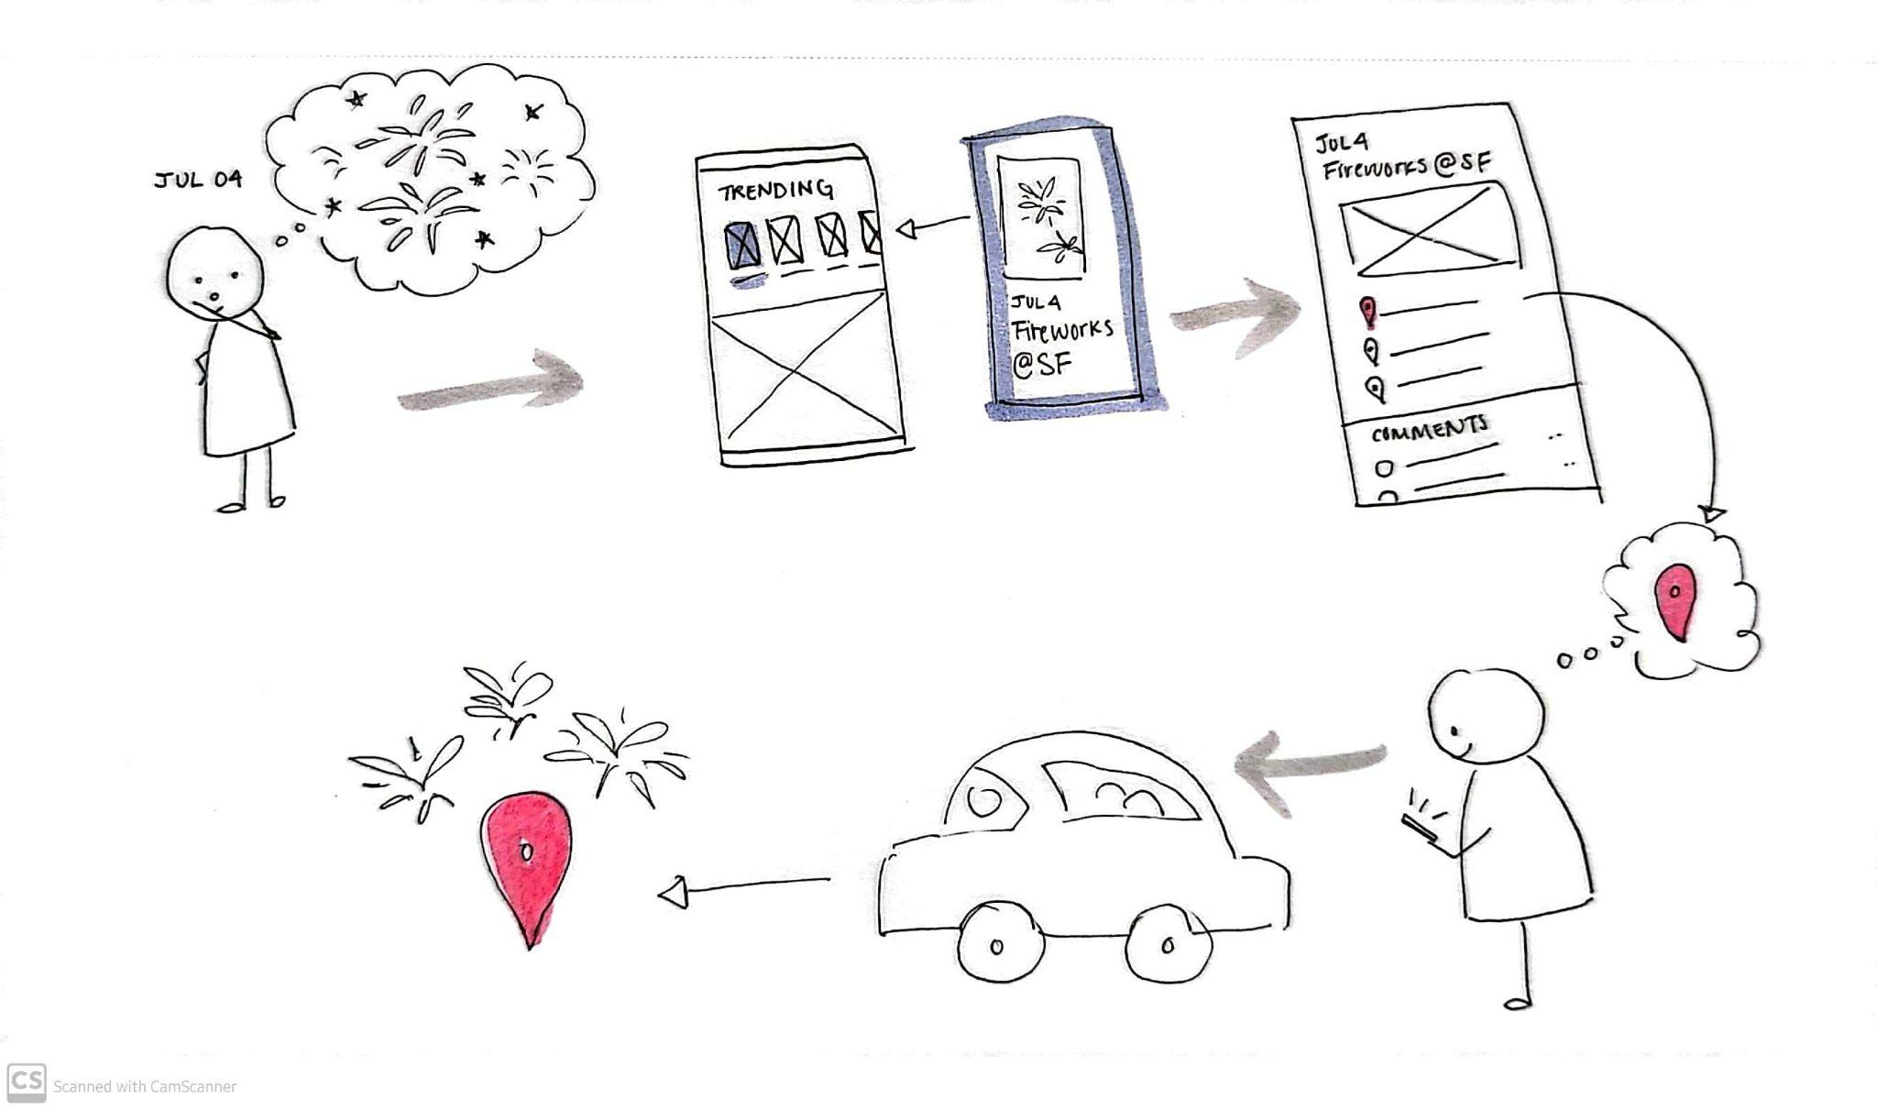

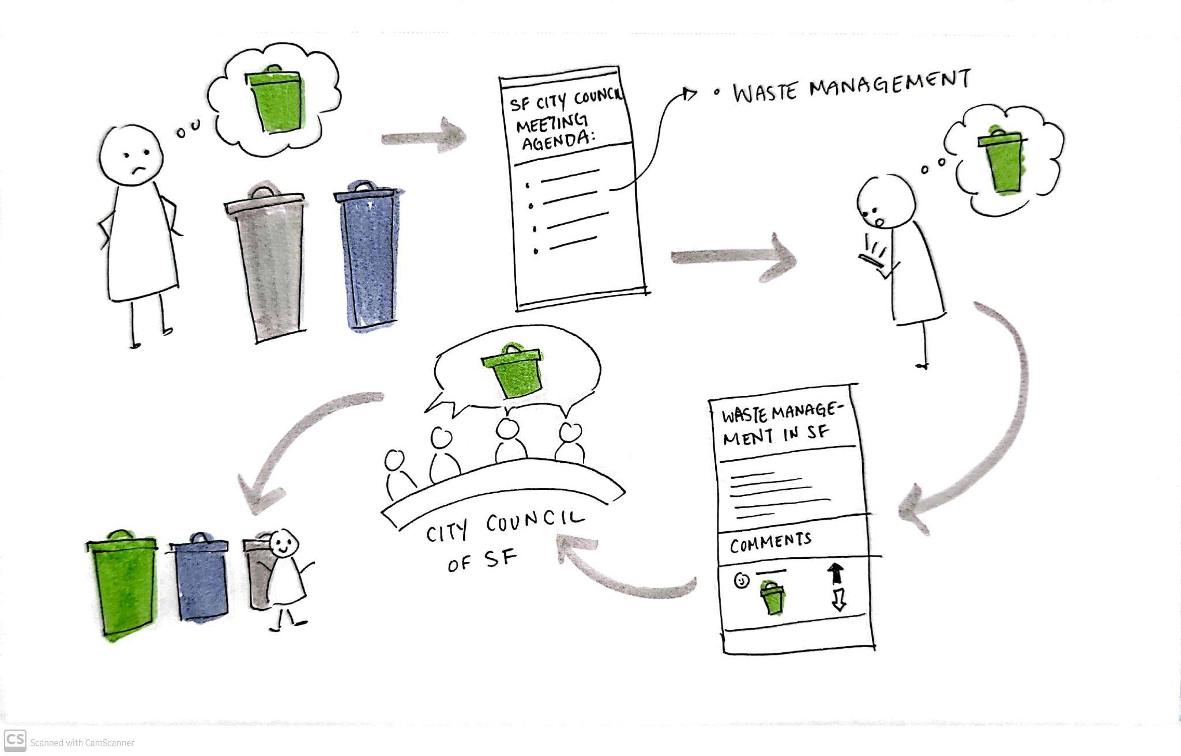

Scenario 3: Voicing a civic opinion Scenario 4: Researching community activities

# Our previous ideas and concepts to support a caring world

1. Fiance Educational App
2. Crime Rate Map
3. Pet Care-taking App
4. Health Monitor / Assistant App
5. Homelessness or Environmental Donation App
6. Job Recruitment App